1. Loligo is classified into which phylum?
a. Annelida
b. Arthropoda
c. Chordata
d. Cnidaria
*e. Mollusca
f. Platyhelminthes

2. What type of symmetry does Loligo have?
*a. bilateral symmetry
b. radial symmetry

3. Loligo has
*a. a complete digestive system
b. a gastrovascular cavity

4. On the squid diagram, the structure labeled "a" is
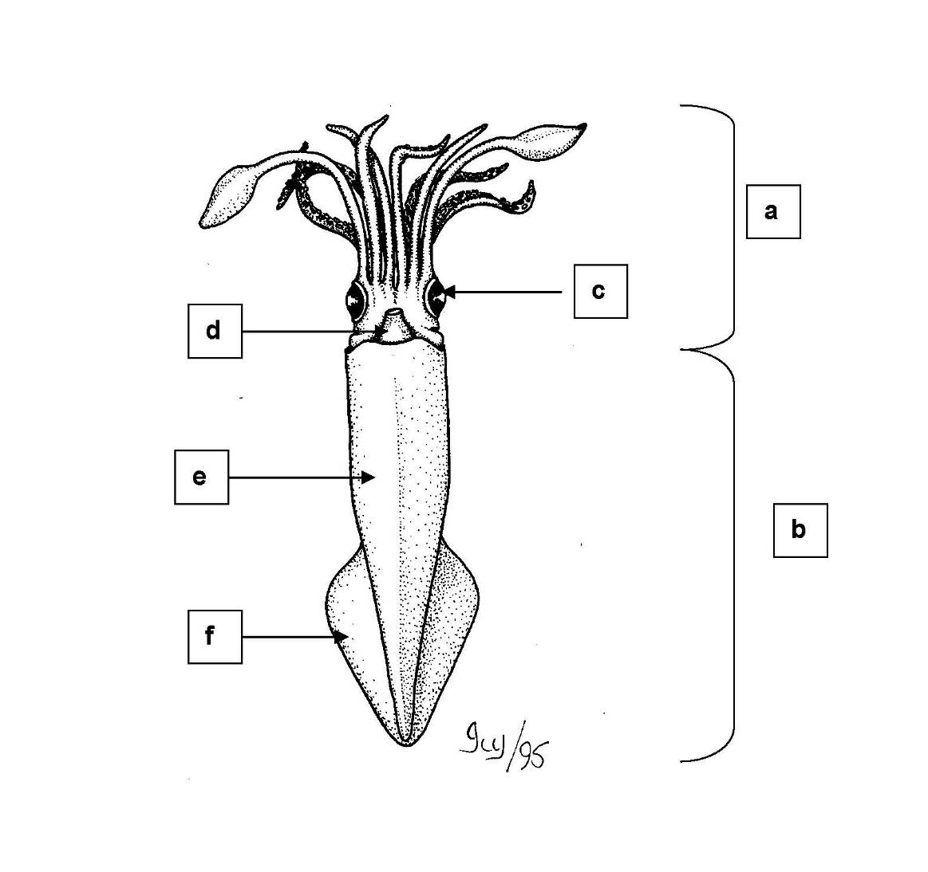

a. body
b. eye
*c. head
d. fin
e. funnel
f. mantle

5. On the squid diagram, the structure labeled "b" is

*a. body
b. eye
c. head
d. fin
e. funnel
f. mantle

6. On the squid diagram, the structure labeled "c" is

a. body
*b. eye
c. head
d. fin
e. funnel
f. mantle

7. On the squid diagram, the structure labeled "d" is

a. body
b. eye
c. head
d. fin
*e. funnel
f. mantle

8. On the squid diagram, the structure labeled "e" is

a. body
b. eye
c. head
d. fin
e. funnel
*f. mantle

9. On the squid diagram, the structure labeled "f" is

a. body
b. eye
c. head
*d. fin
e. funnel
f. mantle

10. On the squid diagram, the structure labeled "a" is
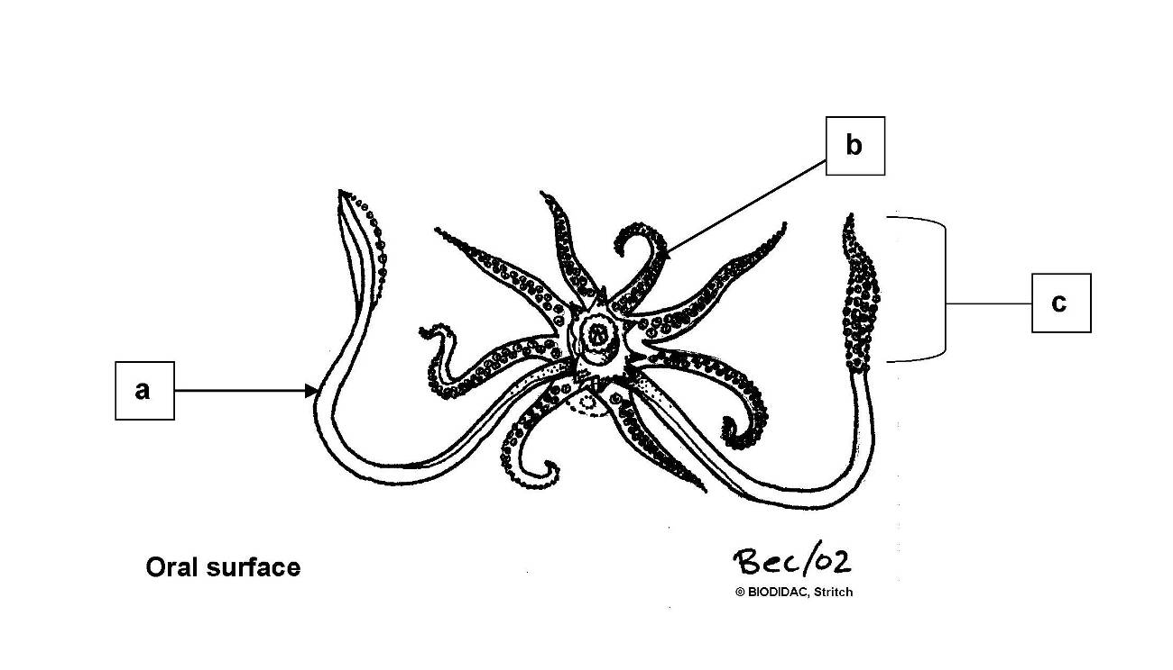

a. arm
*b. tentacle
c. tentacular club

11. On the squid diagram, the structure labeled "b" is

*a. arm
b. tentacle
c. tentacular club

12. On the squid diagram, the structure labeled "c" is

a. arm
b. tentacle
*c. tentacular club

13. On the squid diagram, the structure labeled "a" is
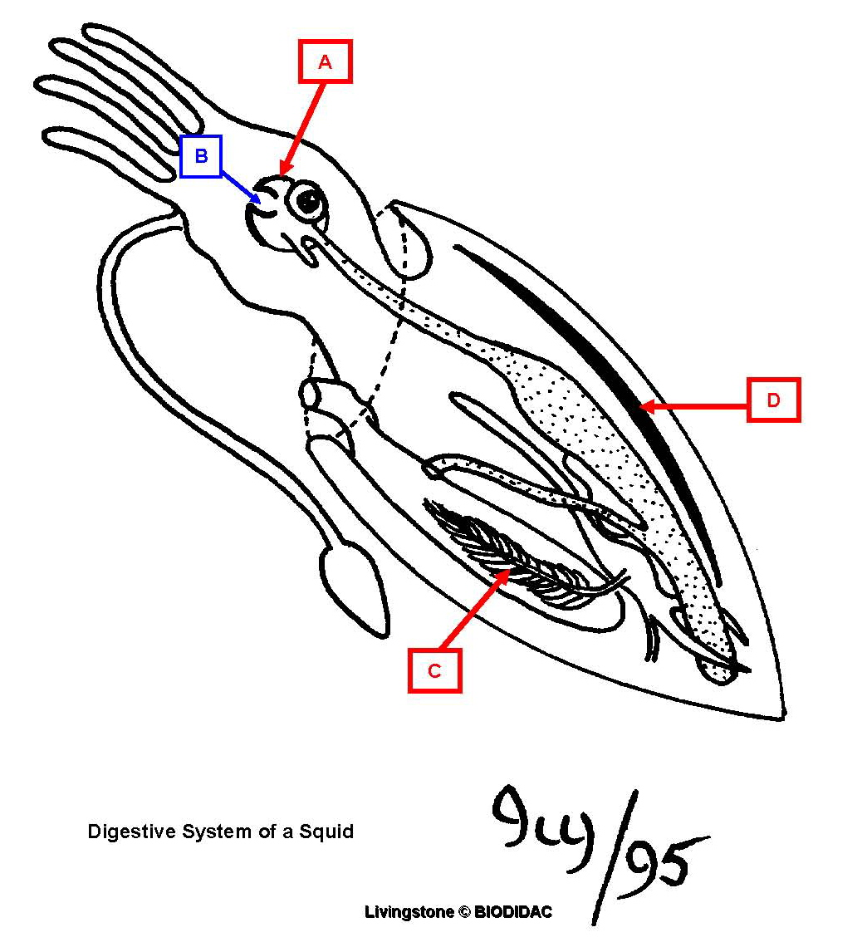

*a. beak
b. gills
c. mouth
d. pen

14. On the squid diagram, the structure labeled "b" is

a. beak
b. gills
*c. mouth
d. pen

15. On the squid diagram, the structure labeled "c" is

a. beak
*b. gills
c. mouth
d. pen

16. On the squid diagram, the structure labeled "d" is

a. beak
b. gills
c. mouth
*d. pen

